**Name:**  Muhammad Bilal

**Father Name:** Haneef Qureshi

**Section:** A

**Teacher:** Miss Erum Shahid

**Course:** CSSE - 313

**Program:** BSSE

**Assignment Topic:** Transport Services in Karachi

**Department:** UBIT

**TRANSPORT SERVICES IN KARACHI**

*Being a Karachiite don't you think how hard it is for all of us to travel from one place to another?*

*How a mega city the size of Karachi survives and functions without a dependable public transport service is still a mystery that puzzles many.*

*Besides the chaos and pain that people go through, the economic cost of insufficient and inefficient public transport is highly unsustainable.*

**Hardships of Travelling**

A Karachiite can't even find a good, reliable, and affordable public transport here in Karachi. Most working-class people can’t afford private vehicles hence they rely on public transport services. However, it is the privately-owned vehicles that dominate the transport services as the **Karachi Transport Etihad** is a managing service of privately owned buses, taxis and rickshaws.

Most use buses and minibuses since they are the least expensive mode, with fares now **Rs15 for 5km and Rs30 for 10-20km**. These are expected to rise further due to increases in fuel prices.

A major problem is that of the overloading of passengers (average of 45 passengers per bus). Over half of the passengers don’t even get a place to sit, especially during rush hours (8am to 9:30am and 5pm to 7pm).

They are forced to stand in the aisle, hang on the edge of the doors or sit on the roof. This problem is mostly because of the shortage of buses available to meet the massive demand.

*Considering the city’s population, there should be* ***20,448 35-seater*** *minibuses and* ***5,566 50-seater*** *buses, but the numbers available are much less than that*

As can be seen from the table, there has been a 57 percent reduction in the number of buses in 15 years, and it has been so due to either buses being scrapped, converted into loading trucks or having moved out of the city.

Of the original **403 planned bus routes, only 165 are operational**. That’s why most passengers must take more than one bus to get to a certain destination or walk long distances from the bus stop to their main destination.

As a result, people either get late for work or sacrifice their comfort to make up for the time they spend in changing buses.

There are numerous behavioural issues observed inside buses. Despite the existence of a partition, **sexual harassment** takes place with incidents of intentional touching or men taking pictures of women without consent. Pick pockets are also common. Drivers sometimes play **vulgar music**, especially during the night, creating a sense of **uneasiness** for some passengers.

Buses don’t follow basic safety standards as there are no formal maintenance checks. Many have broken windows, torn seats and missing doors.

**CNG cylinders** are attached underneath front row seats creating hazardous conditions for those sitting there. Buses often **race against each other**, during traffic, simply to catch more passengers first. Not only does this cause discomfort to passengers, it also leads to accidents at times.

Alternatives to buses are cabs and rickshaws. While they are more comfortable, their **fares are much higher**, with an average rickshaw driver charging ten times more than a bus fare.

In case of cab drivers, the difference is higher even though the fares can be bargained.

These modes are unaffordable for the lower income groups who on average earn Rs200-250 daily. Ride-hailing services such **Careem**, **Uber** and **Bykea** are the most preferred option by middle-class travellers because of their superior facilities and reasonable fares, relative to the local rickshaws and cabs.

They’re successful because they fill the gaps that are present in the current transport setup, but these services are also unaffordable for most of the labour class.

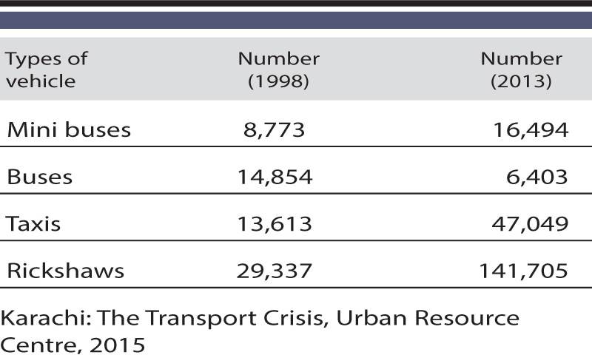Karachi Metropolitan Corporation has announced the Transport Master Plan 2030 where six **bus transit routes (BRT**) have been promised. The routes will cover **95.1km** and provide transport to about **350,000 people** daily.

In 2017, the government had also announced the revival of the now defunct Karachi Circular Railway.

A 50km track was promised to be built, covering all the industrial and urban areas of the city.

But there have been numerous delays in the progress of each of these projects due to conflicts between the federal and provincial governments.

The Sindh government announced Rs5.2 billion for the development of public transport in this year’s budget.

The budget includes financial assistance from the Asian Development Bank and the World Bank for the **Red line and Yellow line** projects, respectively.

*“We are aware of the current problems of the public transport system and that is why we have announced the BRT projects in Karachi. We hope that this will be a positive step towards development”*

* ***Sindh transport minister Awais Shah Qadri***

A student with interest in the urban transport scene sarcastically commented to this,

*“We hope that these upcoming BRT and railway projects are implemented with immediate effect and that they’re maintained up to global standards. We expect that these projects would be corruption free, maintain safety standards and help to meet the mammoth demand of the increasing population”*

Sindh transport minister Syed Awais Qadir Shah told media in July that

*“The Blue Line project has now been put on hold and a tender which had been floated earlier stands cancelled. The reason is very simple. We are short of funds and carrying out work of already launched projects amid so [many] financial challenges. We have not done it willingly but in fact the circumstances led to such an unfortunate decision.”*

He added,

*“The Orange Line is still in the pipeline, but no definitive deadline exists on when it will be ready to run.”*

The discussion around mass transit in Karachi has long been populated by myths, false hopes and indefinitely delayed projects. The famous Karachi Circular Railway (KCR) that was supposed to come into being by a Japanese investment is still nowhere in sight. The Pakistan Railways started the KCR in 1969 but discontinued the service in 1999 due to heavy losses. **The Supreme Court of Pakistan** earlier in the year ordered the KCR to be restarted in a month.

Somehow not foreseeing the confusing effects of an incompetent provincial government, the court order resulted in thousands of people being displaced from their homes which were destroyed to reveal the railway track, but nothing was built after. The victims essentially lost their homes for nothing. The Orange Line is still in the pipeline, but no definitive deadline exists on when it will be ready to run.

The Federal government insists it has a responsibility to intervene as the Sindh government has displayed a complete paralysis in fulfilling the transport needs of Karachi. While most of the route stands ready, the Sindh Government has failed to complete three tenders to procure buses for almost two years now.

In an interview with **Suhail Warraich**, the **Governor Sindh Imran Ismail** said that,

*“He was trying to get the purchase of buses handed over to the federal government so that the people of Karachi can get some immediate relief”*

The **Federal government’s SIDCL(**Sindh infrastructure development company**)** has completed the existing 25-km track of the Greenline at an estimated **Rs.18 billion**, while the procurement of purpose-built buses for the project should cost another **Rs.2.5-3.5 billion**.

Despite these figures, it is possible that the project will be completed in a sum that is lower than the funds that were allotted to it and can possibly return the remainder of the funds to the national exchequer. The procurement of buses is a lengthy process as they will be tailored to the specifications of the track.

**Comparison with App Based Services**

Finding a good transport has always been a problem and people can’t find services here. That’s why services like **Careem , Uber** and **Bykea** came so now you can’t find careem, uber and public transport. The use of these services is not becoming faded.

The reason why ppl are not using careem and uber anymore because their fares are going higher day by day, poor service(in such a way that in some cases the captain will cancel your ride whether you are waiting for him or not), their peak factor(which itself responsible for increment in fares)

Some may think why don’t ppl use **Airlift** and **Swvl** these are the viable options for them. So, the loophole in these services is that they have their fixed routes.

They have their particular point to pick you up. So, the problem people face is what they have to travel 10 to 15 minutes from their place to the pickup point. Undoubtedly their **fares are much reasonable**, and they provide you a **good customer service**.

**Statistics**

As per the World Bank, there should be a **100-seater** bus for every **1,500** people. So, considering **Karachi’s population of 14.91 million**, there should be **20,448 35-seater** minibuses and **5,566 50-seater** buses. But the number of buses plying the roads is much less than that.

Similar facts were mirrored in the **DIG traffic’s 2015 report** which revealed that more than 50 percent buses, minibuses and coaches in the city had disappeared from roads with some 200 routes being shrunk to only 80 over the past decade mainly due to an “increase in fuel prices and government apathy”.

*“Karachi has witnessed the disappearance of over 12,000 public service buses, minibuses and coaches in the last decade,” it further states, while calling for urgent measures to save it from total collapse”*

*“There were 20,000 buses, minibuses and coaches in the city till 2000, but now only 8,000 are operational. Similarly, there were 200 routes of public transport buses and minibuses in the last decade but now 80 are operational”*

Due to not following traffic rules these statistics came up,

“Approximately 20 people out of 100k die in accidents every year making Pakistan rank 67 globally for a higher percentage of accidents.”

According to the World Health Organization (WHO) report (published in 2013),

“Road accidents will become the fifth major cause of deaths by 2030”

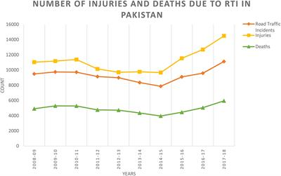

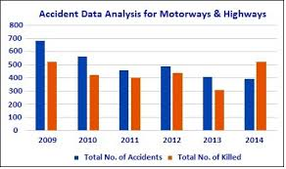

**News Regarding Reforms**

The federal government has issued an international tender for the purchase of 80 buses for the **Green Line Metro**.

According to sources, the federal government has allocated all the funds for the purchase of buses and installation of ITS for the Green Line Metro project.

The tendering process will take 3 months and the successful bidders will import metro buses in 6 to 8 months. The green line bus project will be run by the federal government for 3 years.

**SIDCL (Sindh Infrastructure Development Company Ltd.)** officials say that phase one of the Green Line Bus project is likely to be functional in February 2021. In this regard, SIDCL has also announced that the first batch of buses will arrive in January 2021.

As we all know that Karachi is facing massive shortage of public transport. So, recently **CJP Justice Gulzar Ahmed** asked mayor Karachi,

*“where have all the Karachi buses gone?”*

To which mayor replied,

*“I have no authority”*

There are mega projects such as **blue line** and **green line** under construction and will make transportation conditions less inferior. Still these projects won’t make an immense impact as the infrastructure changes that will follow will be of little use to Karachi’s citizens who direly need a mass transit system on the city’s perpetually choked roads.

Research conducted by the **Japan International Cooperation Agency (JICA)** and renowned urban planners suggest that **the Green, Yellow, Red, Blue, Orange Line** BRTS projects and the revival of the **Karachi Circular Railway (KCR)** will only account for merely 6% of the total public transportation requirements. The city will improbably have an effective transportation system by the year 2030.

**SOLUTION TO THIS PROBLEM**

1. All the stakeholders must accept that Karachi must come under one umbrella, and the city and its mayor get status and powers like mayors of the large city around the world. All the civic agencies must come under one mayor whose election could be held through direct election.
2. Karachi at present hardly has any public transport. In the 80s, Japanese suggested 8,000 large size buses instead of minibuses. After 30 years, the city at least 30,000 large size buses and more incentives should be given to private bus and taxi services.
3. Karachi roads not only need expansion but also immediate removal of encroachment around thousands of service roads, footpaths.
4. It is time to investigate the housing sector in Karachi. Hundreds and thousands of apartments, commercial and residential plazas have been built without basic amenities(which we recently have experienced due to heavy rain fall). Prime land has been distributed or sold on throwaway prices.
5. Government has to start effective awareness programs regarding traffic safety rules.
6. Karachi should have its own Metropolitan Police system like in other big cities of the world. The presence of local police irrespective of ethnicity or caste could be a step forward.
7. Karachi at present has three major industrial zones. It can have more economic zones in consultation with businessmen and traders.
8. Government can invest in services like airlift and swvl which will surely lower the fares of these services.
9. Fresh population census in Karachi is needed to determine its exact population. Without knowing the exact population, it would be impossible to re-plan the most unplanned city.